

 **WMWI**

**The National Federation of WI**’**s campaign to**

**improve women**’**s and family**’**s lives**

**Monthly Newsletter:MAY 2024:203**

 [www.waltonmanorwi.co.uk](http://www.waltonmanorwi.co.uk)  **Walton Manor WI**

** Registered charity 11196**5

** President:** Caroline Coleman -07850 830858

**Secretary:** Clare Wildish - 01865 556018

**Treasurer and Vice President** : Liz Jennings - 07717 756338



**NEXT MEETING WMWI**

**WHEN** Tues 14th May

WHERE St Margaret’s Institute

Polstead Road

TIME 7.30 for 8pm start

Our speaker will be Mary McIntyre

WOMEN ASTRONOMERS

**LAST MONTH**’**S MEETING**

The meeting began with all the members having a lesson on how easy it is to visit our website using their phones.

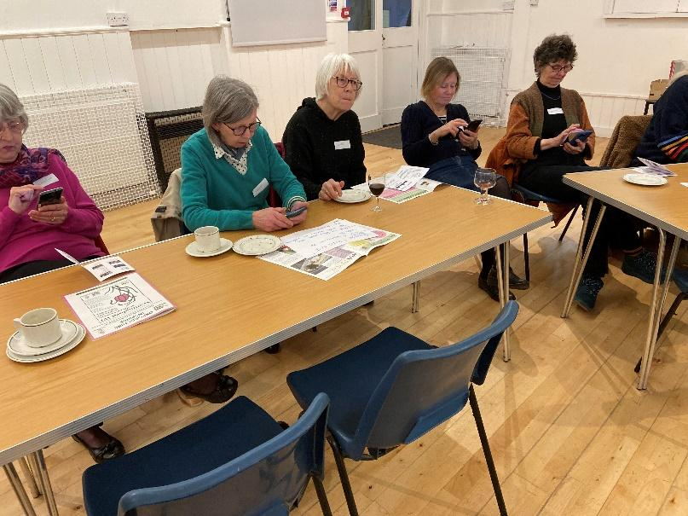

Members were then introduced to the committee

President: Caroline Coleman

Secretary: Clare Wildish

Treasurer: Liz Jennings

Programme Secretary Hilary Godfrey

Membership database Caroline Coleman

Website Hilary Fletcher

Register/rotas Janette Harrington

Newsletter Margaret Partridge

Program Production Anne Wiles

Events Organiser Anne Cashmore

Following on, Jane Finnerty gave us all the ‘fors’ and ‘againsts’ on the resolution for the Annual Meeting in June at the Royal Albert Hall

‘The NFWI calls on the Government to increase investment in the training and retention of dentists and to review the current inadequate NHS contracts in order to ensure everyone can access an NHS dentist wherever they live.’

Members will decide how to vote at our next meeting.

This was followed by an excellent film quiz.

**Lunch club**

10 members went to The Talbot, Eynsham

A jolly time was enjoyed by all

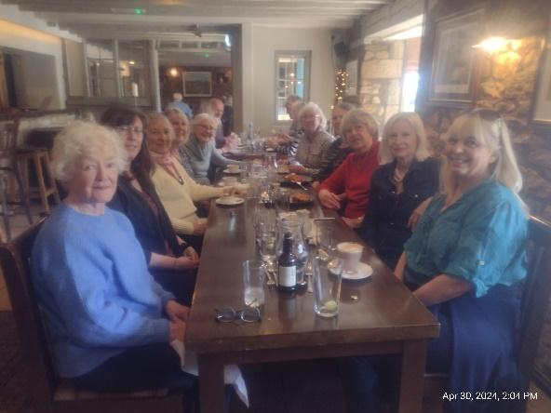

**KELMSCOTT MANOR**

**8 members of Walton Manor spent a very nice morning at Kelmscott Manor, the home of William Morris, his wife Jane, their two daughters and for a few years Dante Gabriel Rossetti, the pre Raphaelite artist who was Jane**’**s lover.**

**It is such a charming house, full of history, very peaceful and one could see the attraction for the family moving here from London.**

**We followed our visit chatting over a good lunch in the cafe and a bit of retail therapy to follow.”**

**A good day was had by all.**

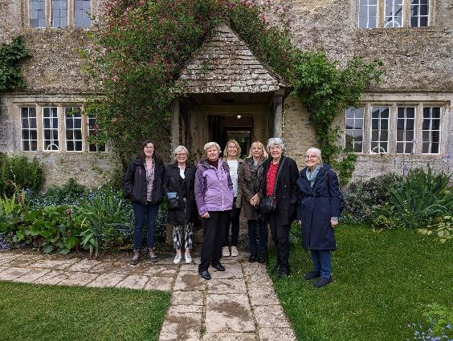

**Some of the tiles/fabrics designed by William Morris**

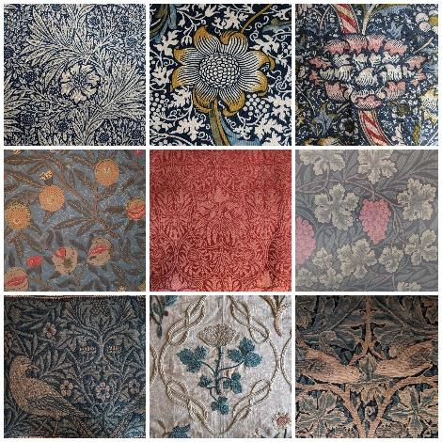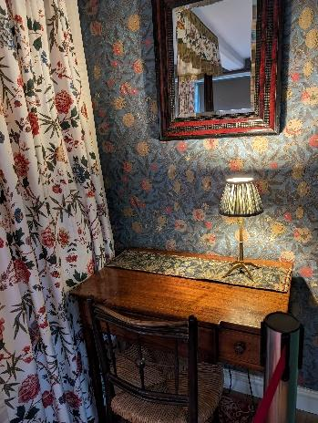

**GROUP MEETING AT YARNTON**

**VILLAGE HALL – 16TH APRIL**

**Several members attended this afternoon meeting. It was nice to see other members of our group. The speaker gave us a very amusing talk about the making of the film The Wizard of Oz. We were served an amazing selection of cakes.**

**Youth Challenge Oxfordshire**

Dear ladies

The project in Kenya challenges Oxfordshire youth to develop life changing skills whilst helping to support a Kenyan community via their school, medical centre, social outreach. I look forward to telling you how your donations have been used in the community, thanks,

Sarah Ewart



**FUTURE EVENTS**

**MAY WALK**

This will take place on Wednesday 15th May. We shall do a circular walk, starting at the Combe entrance to Blenheim Estate, using the right of way through the woody area. Lunch will be at the Oxfordshire Yeoman, Freeland. Please let me know if you can come.

margaret@thecovey.co.uk

**WALTON MANOR KNIT AND NATTER**

The next get together will be on

Tuesday 21st May

From 7 – 9pm

At Catherine’s, 92 Lonsdale Rd, OX2 7ER

Bring along you knitting/sewing etc and enjoy a coffee/tea and a good natter

**OFWI UPCOMING EVENTS FROM OXFORDSHIRE INSPIRES**

**FROM GARDEN TO PLATE**

**11TH June at Benson Parish Hall**

**10.30 – 3.30 £24 non mbrs £27**

A wonderful day out for gardeners AND cooks!

Chris Day will present **“The all-new A-Z of fool-proof gardening’** - a seasonal gallop through 26 letters featuring plants and props along the way. Who knows the “Z” plant? Of course, time for Q&A.

After a delicious two-course lunch we will hear about “**Italy from seed to plate”**featuring vegetables from Roman times to the present day. Then we will go on a food journey around Italy in veg! Paolo’s seeds are heritage, ethical, endangered, and regional varieties with the highest provenance.

Some plants, seeds, fertilisers etc will be on sale plus some fabulous citrus and floral Florentine soaps etc. N.B. One speaker is cash sales only.

*********

**BLETCHLEY PARK**

**Sat 22nd June £51 non mbrs £55**

**08.00 – 20.00**

Join us for a visit to the world-famous WWII Government Code and Cypher School

*********

**A Unique Opportunity to visit The Defence Academy of the UK, Shrivenham**

Tues 9th July 08.00 to 1800

Cost £26

We are delighted to be able to offer members this unique opportunity to visit this amazing facility in Oxfordshire. It has over 150 buildings on a 660 acre site which is not normally open to the public.

The Defence Academy delivers world-class professional defence and security education to students from the UK Armed Forces, Civil Service, industry and overseas. It is part of the Ministry of Defence.

We will travel by coach to the facility where we will be met by military personnel who will accompany us on a tour of the site and an opportunity to visit some of the buildings.

The day will start with coffee in the Cormorant building and a presentation about the history and function of the Academy. We will then tour the site on the coach which includes the historic Beckett House, the Tank Room and the new Chaplaincy Museum.

You will be able to purchase lunch in one of the three eateries on site, or bring your own packed lunch if you prefer

**********

**A Day Trip to Blists Hill Victorian Town and Ironbridge,Telford**

**Thursday 11th July cost £58 non Mbrs £62**

Come with us to the wonderful Victorian town of Blists Hill in Shropshire. Step back in time to where traditional life and industry were a far cry from today. Enter Victorian shops and cottages, taste authentic food and sweets and watch demonstrations of crafts of the day. The site uses token pounds, shillings and pence – remember them? There are plenty of opportunities for refreshments either here or later when we travel the short distance to the UNESCO WORLD Heritage site of Ironbridge. Here you are able to visit various museums, including the Museum of the Gorge or the Coalport China Museum. Some of the attractions are free, and during this free time you can choose the ones you would like to visit. ‘The Ironbridge’ itself, the world’s first made entirely of cast iron, is a definite must. Do book for this excellent day out.

**ALL THE ABOVE EVENTS AND MORE INFORMATION. INCLUDING CLOSING DATES, CAN BE FOUND IN OXFORDSHIRE INSPIRES OR ON THE OFWI WEBSITE**